Course title: Database Design and Implementation

Class #: 1225_91809 Teacher: Rachida Amjoun

Group Members

Lovepreet Singh (991628858)

Navjit Kaur (991617153)

Asmabanu Saiyed (991578249)

INTRODUCTION 3

CONCEPTUAL MODEL 4

ER DIAGRAM ELABORATION. 5

DATA STRUCTURE DIAGRAM 6

EXPLANATION OF DATA STRUCTURE DIAGRAM 7

CREATING TABLES 8

INSERTING DATA 14

MONGO DATABASE CODING 17

MONGO DATABASE COLLECTIONS 22

# INTRODUCTION

The main vision of this fitness project is to implement and design the database. The conceptual model and relational model will be explained in this fitness proposal. After covering these parts, we have explained how this database is in 3NF. From here we can see the main entities are location, amenity, coaches, and certificates.

# CONCEPTUAL MODEL

# ER DIAGRAM ELABORATION.

With the use of a diagram known as an Entity Relationship Diagram, an Entity-Relationship Model illustrates the structure of a database. A database design or blueprint known as an ER model can subsequently be implemented as a database. Entity set and relationship set make up the bulk of the E-R model.

As we can see Class has a name, time, and price which are attributes of Class. A location can have many classes. A coach can have many classes.

The review has these attributes named as date, communication, description, and punctuality. Clients must write one review. Coaches must have at least one review from the client.

A client has a name, email address, and telephone number. Clients can visit any location.

A coach has a name, level, and description. Coaches can have many references and certificates.

A location can have a name, email, address, and telephone number. This location can be visited by any client. A location might have many amenities.

# DATA STRUCTURE DIAGRAM



# EXPLANATION OF DATA STRUCTURE DIAGRAM

The entity-relationship model was preceded by data structure diagrams. In DSDs, attributes are defined inside entity boxes as opposed to outside of them, and relationships are represented by boxes made up of attributes that define the connections between entities. The E-R model and DSDs focus on the relationships of the elements inside an entity, while the E-R model emphasizes the relationships between various entities in the diagram, we created the table, and each table has the primary key and as well as foreign key as required. The relational diagram is made with the help of the conceptual diagram which we made earlier. Every table has a unique name (Client, Coach, Location, Class etc). The diagram is 1NF because the order of columns is not an issue, and it can be unordered. In the model, no half dependencies exist which makes it 2NF. The model is 3NF because the model has no transitive dependencies on PK in any of the tables. In the case of the relationship between the tables, REL_Client-Class has the many to many relationships between the client and class. Similarly, REL_Coach,, REL-LOCATION-AMENITY, REL-CERTIFICATE, REL_REFERENCE have the mamy to many relationships.

# CREATING TABLES

create table Coach

(

Coach_ID int,

NAME VARCHAR(100) not null,

DESCRIPTION VARCHAR (3000) not null,

level int not null,

primary key (Coach_ID)

);

create table Certificate

(

CertificateID int ,

NAME VARCHAR(300) not null,

primary key (CertificateID)

);

create table Reference

(

ReferenceID int ,

CLIENTNAME VARCHAR(300) not null,

MOBILEPHONE VARCHAR(200) not null,

EMAIL VARCHAR(200) not null,

primary key (ReferenceID)

);

create table Client

(

ClientID int,

NAME VARCHAR(200) not null,

TELEPHONE VARCHAR(200) not null,

EMAIL VARCHAR(200) not null,

primary key (ClientID),

);

create table REL_COACH_REFERENCES

(

COACHID int not null,

REFERENCEID int not null,

foreign key (COACHID) references Coach,

foreign key (REFERENCEID) references Reference

);

create table REL_COACH_CERTIFICATE

(

COACHID int not null,

CERTIFICATEID int not null,

foreign key (COACHID) references COACH,

foreign key (CERTIFICATEID) references CERTIFICATE

);

create table Location

(

Location_ID int,

NAME VARCHAR(100) not null,

ADDRESS VARCHAR(3000) not null,

TELEPHONE VARCHAR(200) not null,

EMAIL VARCHAR(3000) not null,

primary key (Location_ID)

);

create table Room

(

RoomID int,

LocationID int not null,

NAME VARCHAR(200) not null,

primary key (RoomID),

foreign key (LocationID) references LOCATION

);

create table REL_COACH_CLIENT

(

COACHID int not null,

CLIENTID int not null,

foreign key (COACHID) references Coach,

foreign key (CLIENTID) references Client

);

create table Review

(

Review_ID int,

COACHID int not null,

CLIENTID int not null,

COMMUNICATION int not null,

ENTHUSIASM int not null,

PUNCTUALITY int not null,

DESCRIPTION VARCHAR(3000),

primary key (Review_ID),

foreign key (COACHID) references Coach,

foreign key (CLIENTID) references Client

);

create table REL_REVIEW_COACH

(

COACHID int not null,

REVIEWID int not null,

foreign key (COACHID) references Coach,

foreign key (REVIEWID) references Review

);

create table REL_REVIEW_CLIENT

(

CLIENTID int not null,

REVIEWID int not null,

foreign key (CLIENTID) references Client,

foreign key (REVIEWID) references Review

);

create table Class

(

ClASS_ID int,

NAME VARCHAR(100) not null,

PRICE int not null,

TIME int not null,

primary key (CLASS_ID),

);

create table REL_CLIENT_ROOM

(

ROOMID int not null,

CLIENTID int not null,

foreign key (ROOMID) references Room,

foreign key (CLIENTID) references Client

);

create table REL_COACH_ROOM

(

COACHID int not null,

ROOMID int not null,

foreign key (ROOMID) references Room,

foreign key (COACHID) references Coach

);

create table REL_CLIENT_CLASS

(

CLASSID int not null,

CLIENTID int not null,

foreign key (CLASSID) references Class,

foreign key (CLIENTID) references Client

);

create table Amenity

(

AmenityID int,

NAME VARCHAR(200) not null,

primary key (AmenityID)

);

create table REL_LOCATION_AMENITY

(

LOCATIONID int not null,

AMENITYID int not null,

foreign key (LOCATIONID) references Location,

foreign key (AMENITYID) references Amenity

);

# INSERTING DATA

INSERT INTO COACH (Coach_ID, NAME, DESCRIPTION, "level") VALUES(1,'Haraman','Your Personal Tranner',5 );

INSERT INTO COACH (Coach_ID, NAME, DESCRIPTION, "level") VALUES(2,'Manpreet','Fit For Less',3);

INSERT INTO Certificate(CertificateID ,Name)VALUES(1,'Weight Lifting');

INSERT INTO Certificate(CertificateID ,Name)VALUES(2,'Cardio');

INSERT INTO Certificate(CertificateID ,Name)VALUES(3,'Diet Plan');

INSERT INTO Reference(ReferenceID , CLIENTNAME, MOBILEPHONE,EMAIL)VALUES('ABC','SUNIL',654789654,'nvhf987@gmail.com');

INSERT INTO Reference(ReferenceID , CLIENTNAME, MOBILEPHONE,EMAIL)VALUES('Man','Harsh',647896954,'Singh345@gmail.com');

INSERT INTO Client(ClientID , Name, Telephone,EMAIL)VALUES(33,'Jagreet',99876543234567,'kbjgf234@gmail.com');

INSERT INTO Client(ClientID , Name, Telephone,EMAIL)VALUES(83,'',34578934567,'hjur@gmail.com');

INSERT INTO REL_COACH_CERTIFICATE(COACHID , CERTIFICATEID)VALUES(23,67);

INSERT INTO REL_COACH_CERTIFICATE(COACHID , CERTIFICATEID)VALUES(3,7);

INSERT INTO REL_COACH_CERTIFICATE(COACHID , CERTIFICATEID)VALUES(2,6);

INSERT INTO REL_COACH_CERTIFICATE(COACHID , CERTIFICATEID)VALUES(9,5);

INSERT INTO Location(Location_ID,NAME,ADDRESS,TELEPHONE,EMAIL)VALUES(56,'Sam', '67 Jalandhar',789654345,'Ljk567@gmail.com');

INSERT INTO Location(Location_ID,NAME,ADDRESS,TELEPHONE,EMAIL)VALUES(98,'Sukhman', '67 Mumbai',879654345,'sukh567@gmail.com');

INSERT INTO Room(RoomID ,LocationID,NAME)VALUE(9,'Sheridan' ,'Yash');

INSERT INTO Room(RoomID ,LocationID,NAME)VALUE(69,'Humber' ,'Zorawar');

INSERT INTO REL_COACH_CLIENT(COACHID ,CLIENTID)VALUES(5,7);

INSERT INTO REL_COACH_CLIENT(COACHID ,CLIENTID)VALUES(7,5);

INSERT INTO Review(Review_ID , COACHID,CLIENTID, COMMUNICATION,ENTHUSIASM,PUNCTUALITY,DESCRIPTION)VALUES(2,4,1,2,1,'abc abc abc');

INSERT INTO Review(Review_ID , COACHID,CLIENTID, COMMUNICATION,ENTHUSIASM,PUNCTUALITY,DESCRIPTION)VALUES(3,5,6,1,2,'cde hjc juc');

INSERT INTO REL_REVIEW_CLIENT (CLIENTID,REVIEWID)VALUES(8,4);

INSERT INTO REL_REVIEW_CLIENT (CLIENTID,REVIEWID)VALUES(98,14);

INSERT INTO Class ( ClASS_ID ,NAME,PRICE,TIME)VALUES(5,'HARSH',50,60);

INSERT INTO Class ( ClASS_ID ,NAME,PRICE,TIME)VALUES(8,'Nav',36,30);

INSERT INTO REL_CLIENT_ROOM(ROOMID,CLIENTID) VALUES(7,9);

INSERT INTO REL_CLIENT_ROOM(ROOMID,CLIENTID) VALUES(8,2);

INSERT INTO REL_CLIENT_ROOM(ROOMID,CLIENTID) VALUES(79,19);

INSERT INTO REL_COACH_ROOM(COACHID, ROOMID)VALUES(8,7);

INSERT INTO REL_COACH_ROOM(COACHID, ROOMID)VALUES(2,7);

INSERT INTO REL_CLIENT_CLASS( CLASSID , CLASSID )VALUES(9,1);

INSERT INTO REL_CLIENT_CLASS( CLASSID , CLASSID )VALUES(29,51);

INSERT INTO REL_CLIENT_CLASS( CLASSID , CLASSID )VALUES(89,11);

INSERT INTO Amenity( AmenityID, NAME)VALUES(508,'lOVE');

INSERT INTO Amenity( AmenityID, NAME)VALUES(98,'Rajvir');

INSERT INTO Amenity( AmenityID, NAME)VALUES(78,'Nav');

INSERT INTO REL_LOCATION_AMENITY (LOCATIONID, AMENITYID)VALUES(607,340);

INSERT INTO REL_LOCATION_AMENITY (LOCATIONID, AMENITYID)VALUES(69,30);

INSERT INTO REL_LOCATION_AMENITY (LOCATIONID, AMENITYID)VALUES(7,40);

INSERT INTO REL_LOCATION_AMENITY (LOCATIONID, AMENITYID)VALUES(907,840);

# MONGO DATABASE CODING

**Coach**

{

"_id": {

"$oid": "62f59941d5ae2b9a1b48f0f6"

},

"coachName": [

"Sally",

"Adam",

"Sander"

],

"Coachrating": [

{

"SallyRating": 5,

"AdamRating": 4,

"SanderRating": 5

}

],

"CoachLevel": [

{

"SallyLevel": 3,

"AdamLevel": 2,

"SanderLevel": 3,

"time": "09:50"

}

]

}

**CoachSally**

{

"_id": 11112222,

"name": "Sally",

"level": 3,

"certificates": [

"Advanced Fit",

"Massage II",

"BikramYoga"

],

"locations": [

"Middletown",

"Traflgar",

"Square One"

],

"classes": [

{

"price": 8,

"gym": "East View",

"name": "Yoga",

"room": " Small Studio",

"time": "9:50"

}

],

"references": [

"Lovepreet Singh",

"Navjit Kaur",

"Asmabanu Saiyed"

]

}

**Location**

{

"_id": 11112222,

"name": [

"Midtown",

"Cabbagetown",

"East View"

],

"timevisited": [

{

"MidtownVisited": "15",

"CabbagetownVisited": "8",

"EastViewVisited": "3"

}

]

}

**MidtownLocation**

{

"_id": 11112222,

"address": " 87 Done Drive Brampton",

"phone": {

"$numberLong": "2895446940"

},

"name": "Middletown",

"email": "admin@gmail.com",

"visited": "15",

"amenities": [

"Sauna",

"Green Zone",

"Hot Yoga",

"Spinning",

"Pool"

],

"coaches": [

"Sayad",

"Lalya",

"Mark"

]

}

# MONGO DATABASE COLLECTIONS

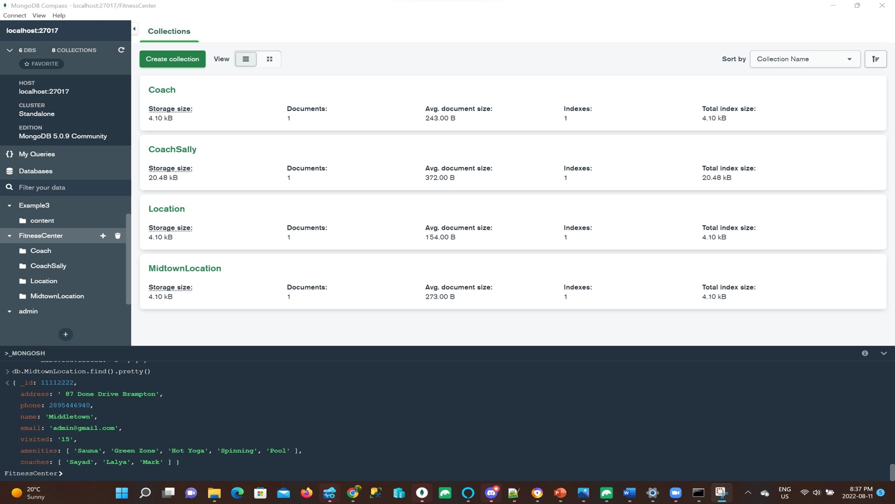

Return all the information displayed on the Coaches tab (wireframe 3)

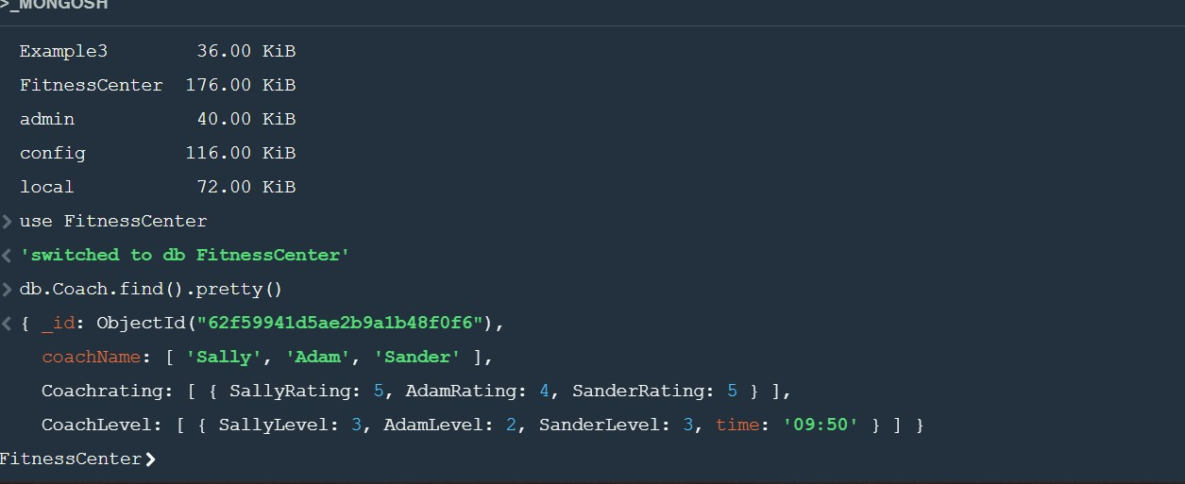

Return all the information displayed on the Coach Sally tab (wireframe 4)

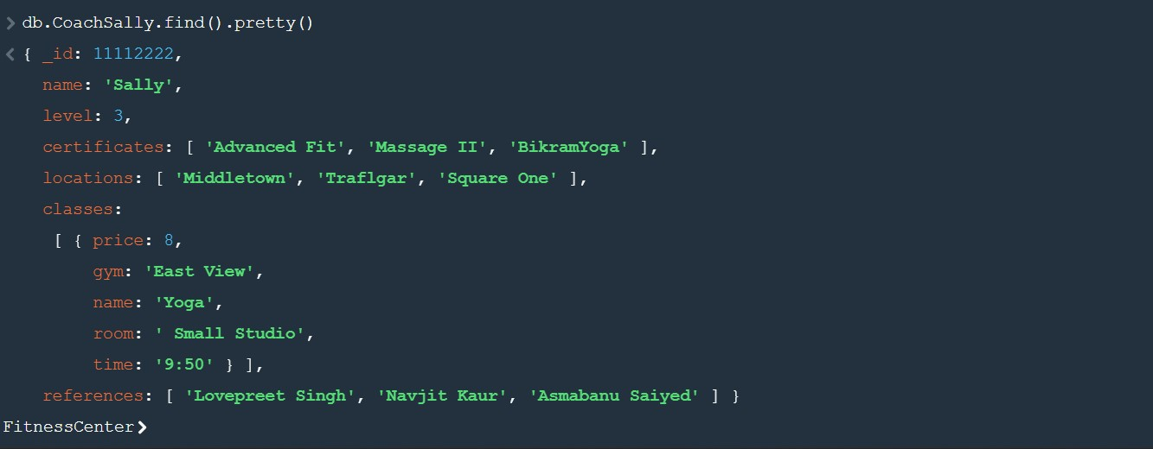

Return all the information displayed on the Locations tab (wireframe 1)

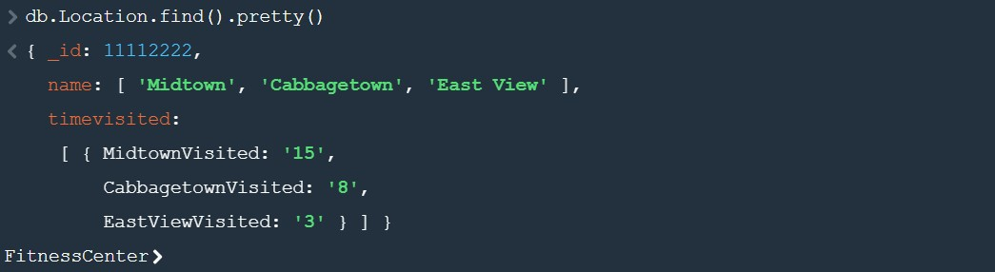

Return all the information displayed on the Midtown Location tab (wireframe 1)

